read me

jenkins initialisation from laptop

After installing jenkins on the laptop

Type this command on command window - httpPort can be 8080 or any

java -jar jenkins.war -httpPort=9090

and then in chrome or firefox browser type localhost:9090

Jenkins Dashboard can be viewable on browser

go and click on new project(for creating) we already have a soapui project

in the configuration--> build write the bellow command

cd C:\Users\172739724\eclipse-workspace\SOAPUI

javac -classpath lib/\* -d ./bin ./src/Rest/\*.java

javac -classpath lib/\* -d ./bin ./src/soap/\*.java

java -cp bin;lib/\* org.testng.TestNG testng.xml

build now --> trigger/run the project

console output--> to view output

SoapUi

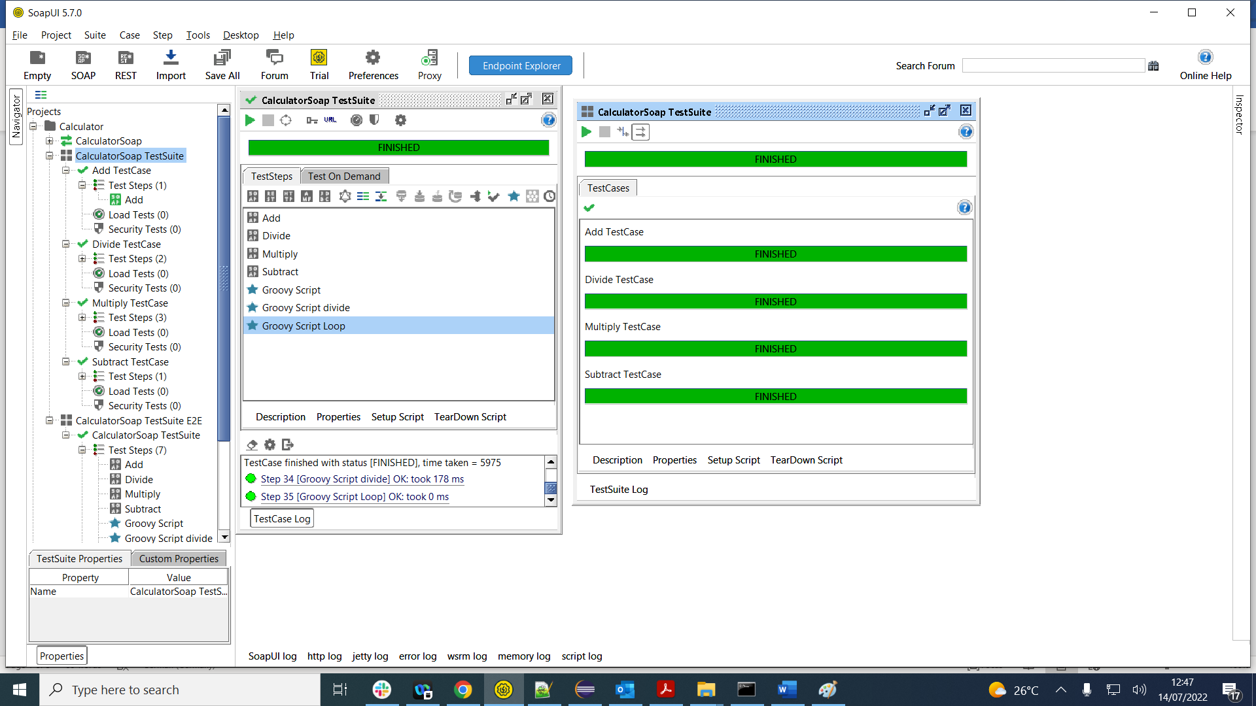

Eclipse via java code triggering soap project

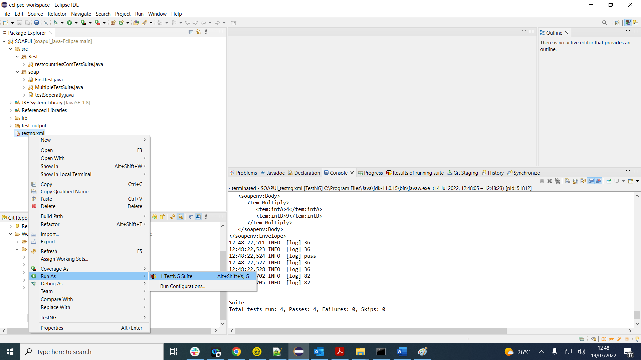

And finally via jenkins

